**Receipt Printer**

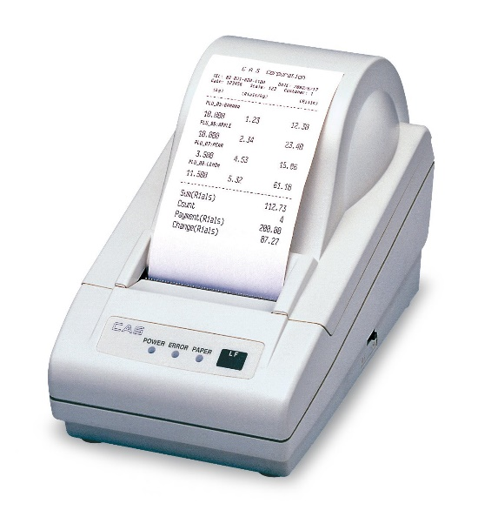

|  |  |
| --- | --- |
| Product Name | Receipt printer DEP-50 |
| Purpose | - Give receipts to customers  - Keep receipts from cashiers |
| Quantity | - 3 |
| User | - Cashiers |

Printer

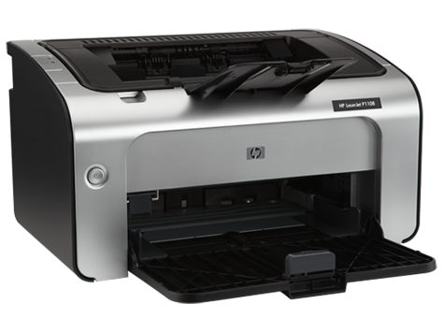

|  |  |
| --- | --- |
| Product Name | HP LaserJet Pro P1108 Printer |
| Purpose | - Take out reports |
| Quantity | - 2 |
| User | - Branch Manager, Store men |

Router

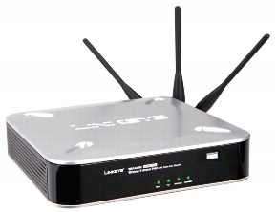

|  |  |
| --- | --- |
| Product Name | Cisco WAP4400N Wireless-N |
| Purpose | - Connect internal LAN and internet |
| Quantity | - 2 |
| User |  |

Switch

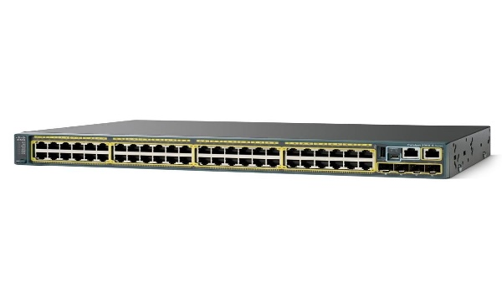

|  |  |
| --- | --- |
| Product Name | WS-C2960S-48TS-L |
| Purpose | - Connect computer , printer and routers |
| Quantity | - 2 |
| User |  |

Tablet

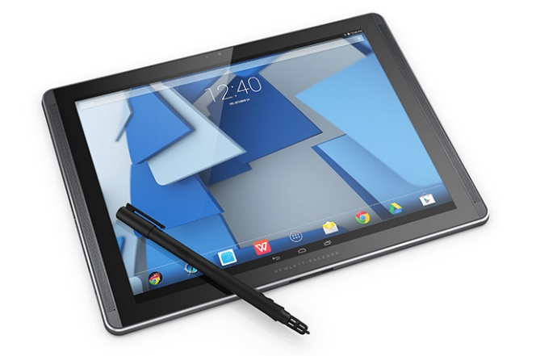

|  |  |
| --- | --- |
| Product Name | HP Pro Sale 8 |
| Purpose | - To maintain data when checking the items |
| Quantity | - 10 |
| User | - Promoters |

Personal Computer

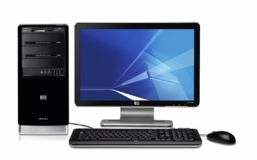

|  |  |
| --- | --- |
| Product Name | HP 3500 Pro |
| Purpose | - To input and update data  - To view reports |
| Quantity | - 6 |
| User | - Branch Manager, Cashiers, Store men |

Barcode Reader

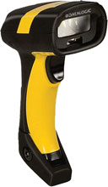

|  |  |
| --- | --- |
| Product Name | Data logic PD8330 Barcode Scanner |
| Purpose | - To read and identify items which are bought by customers. |
| Quantity | - 3 |
| User | - Cashier |

Server

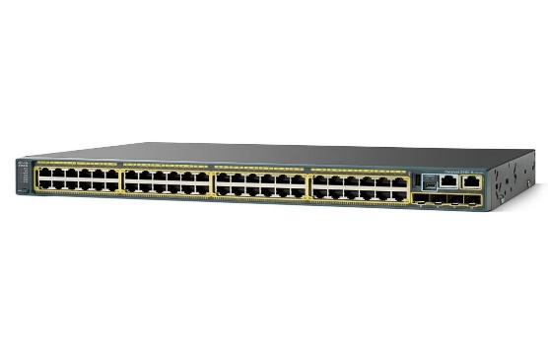

|  |  |
| --- | --- |
| Product Name | Dell PowerEdge R210 II server |
| Purpose | - To store data, website and send email |
| Quantity | - 3 |
| User |  |

Firewall

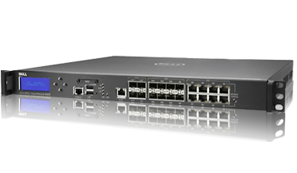

|  |  |
| --- | --- |
| Product Name | Dell Sonicwall |
| Purpose | - To protect and filter data and check network traffic |
| Quantity | - 1 |
| User |  |